# Docker Challenge Notes (Tutorial)

Name: YuQing Ma

Student ID：000869377

Challenge 3 –

1. The first step is to modify the Dockerfile in the db folder to change the paths to relative paths.

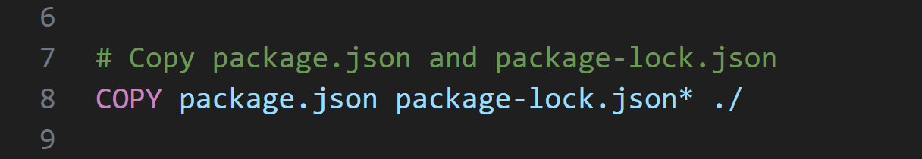

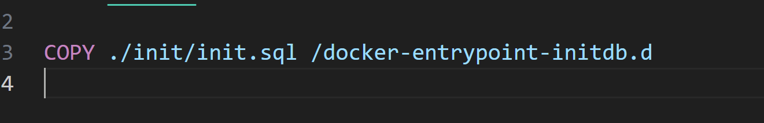

2. The second step is to write the .env parameter documentation.

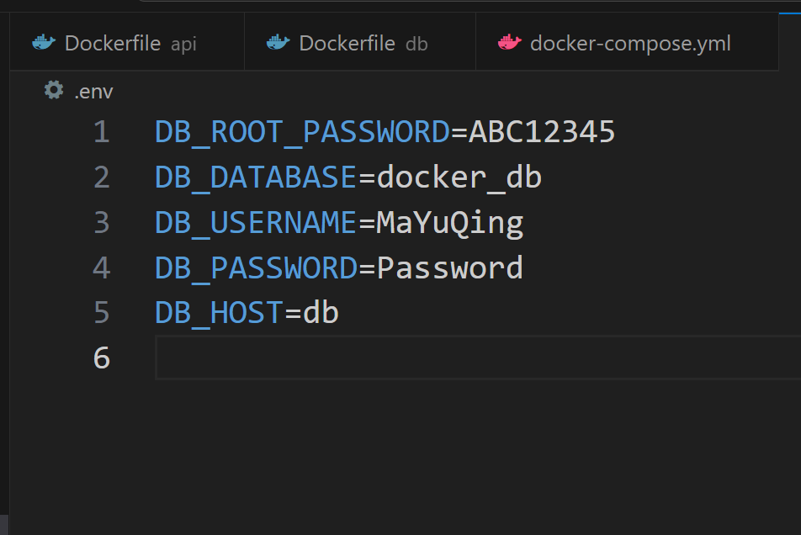

3. The third step is to write the Docker-compose YAML document. Make sure to write the paths correctly.

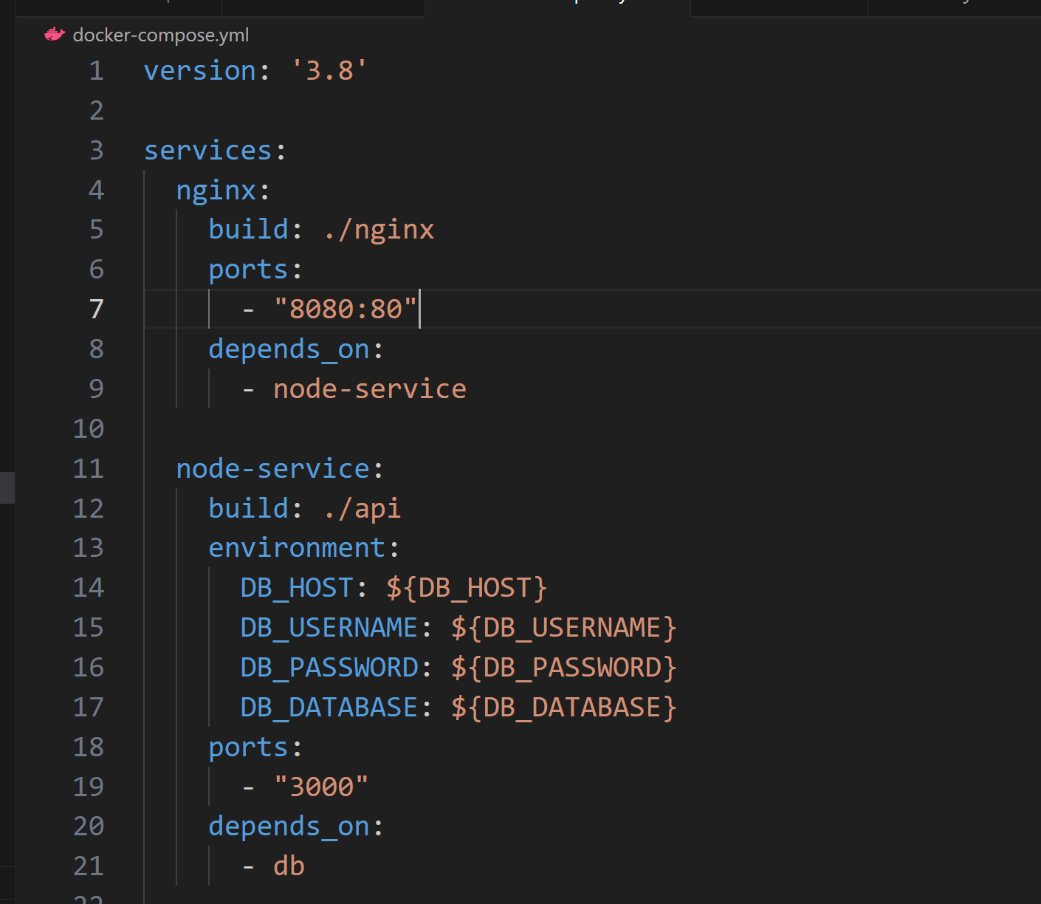

4. Use the command "docker-compose up --build" to create a new container.

5. Check if the container is running properly.

6. Test the container's running status by using "http://localhost:8080/api/books" and "http://localhost:8080/api/books/1".

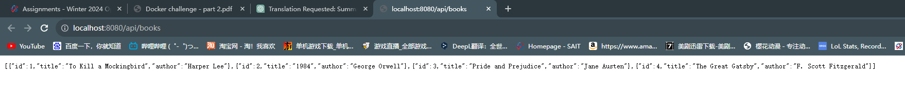

## Challenge 4

7. Use the command "docker-compose up --scale node-service=3 -d" to scale up the node-service from 1 to 3 instances.

8. Check if the scale up was successful.

9. Test using the link "http://localhost:8080/api/stats". Record the hostnames as follows: ab09d8ad2a0b, 177f2085287b, 54e941cafb12.





